Chapter 9 Homework:
- Determine a state variable model, {A,b,c,d} for the circuit shown. u(t) is the input and y(t) is the output.
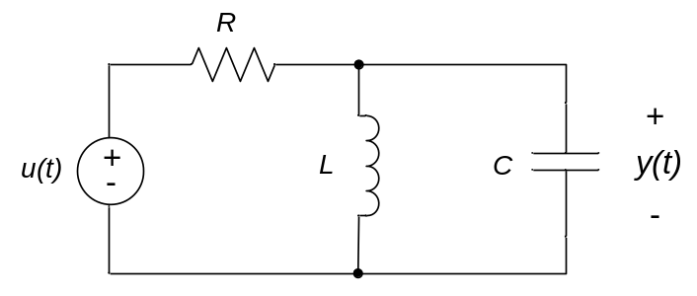
- Determine a state variable model, {A,b,c,d} for the circuit shown. u(t) is the input and y(t) is the output.
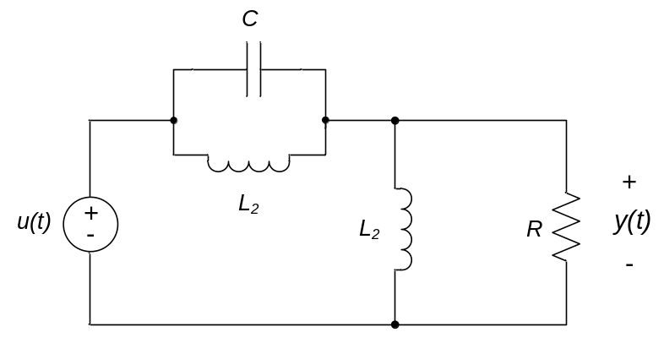
- For the circuit below,
- Determine a state variable model, {A,b,c,d} if V_{in}(t) is the input and V_{out}(t) is the output.
- Simulate and plot (using MATLAB or Octave) the response V_{out}(t) of the circuit if R = 470 Ω, C = 1μF, and the input V_{in}(t) = 4u₀(t), where u₀(t) is the unit step function. From your plot, estimate the time constant of the circuit.
- Estimate the time constant of the circuit from the capacitance and equivalent resistance seen by the capacitor. Compare this value to the time constant estimated from the simulated response. Comment on any differences.
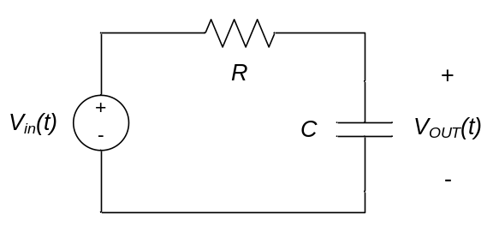
- For the circuit below,
- Determine a state variable model, {A,b,c,d} if V_{in}(t) is the input and V_{out}(t) is the output.
- Simulate and plot (using MATLAB or Octave) the response V_{out}(t) of the circuit to an input V_{in}(t) = 3u₀(t), where u₀(t) is the unit step function. From your plots, estimate the maximum overshoot and rise time of the response.
- Determine an input-output relationship for the circuit and estimate the natural frequency, damping ratio, and final value V_{out}(t→∞). From these, estimate the maximum overshoot and rise time of the response. Compare these values to those measured from your simulation. Comment on any differences.
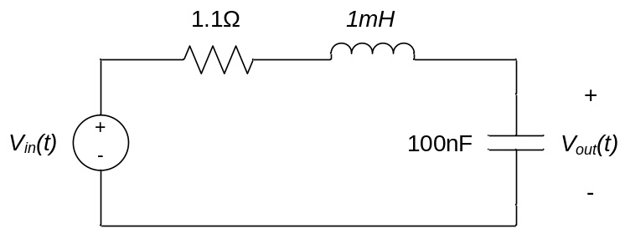
- For the circuit below,
- Determine a state variable model, {A,b,c,d} if V_{in}(t) is the input and V_{out}(t) is the output.
- Simulate and plot (using MATLAB or Octave) the response of the circuit to an input V_{in}(t) = 2u₀(t), where u₀(t) is the unit step function.
