Chapter 8 Homework:
- For the circuit below,
- Determine the second order differential equation governing v(t).
- Find R so that the circuit is critically damped.
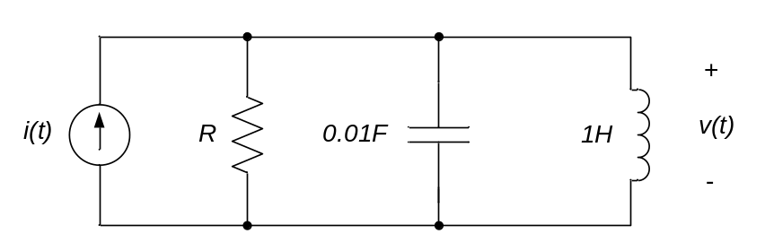

- For the circuit below,
- Determine the differential equation that governs v_{C}(t), t>0.
- Is the system under, over, or critically damped?
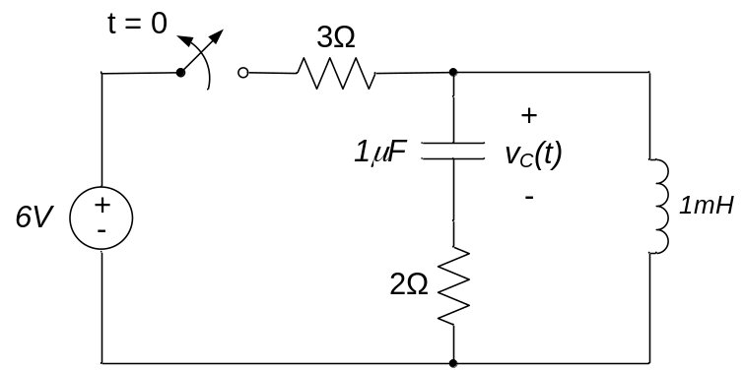

- For the circuit below,
- Determine the differential equation for i_{L}(t), t>0.
- Determine the initial (t=0+) and final (t→∞) conditions on v_{C}(t) and i_{L}(t).
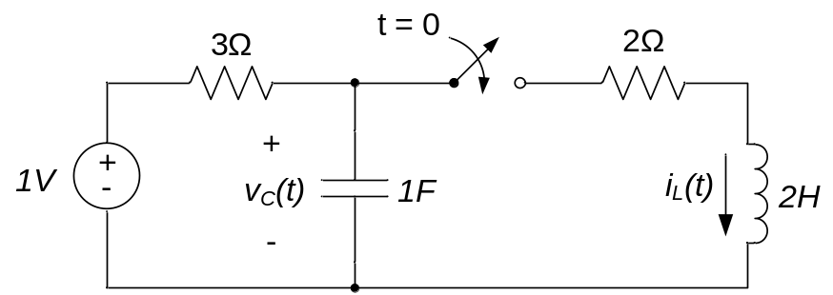
- The switch moves from position A to position B at t=0 seconds.
- Determine the differential equation that governs i_{L}(t), t>0.
- Determine initial (t=0+) and final (t→∞) conditions on v_{C}(t) and i_{L}(t).
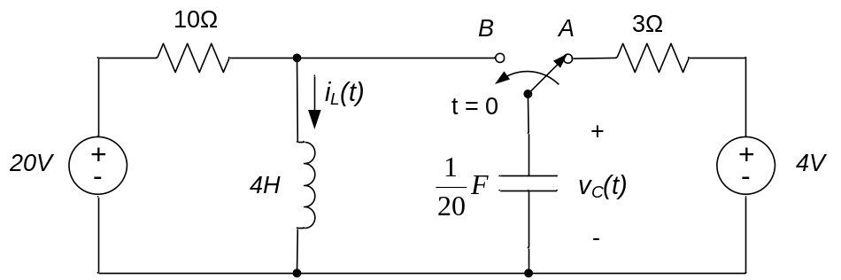
- For the circuit below,
- Determine the differential equation governing i(t).
- Determine ζ and ωn
- Find the maximum value of current through the resistor in response to a step input
u(t) = 3u₀(t) A.
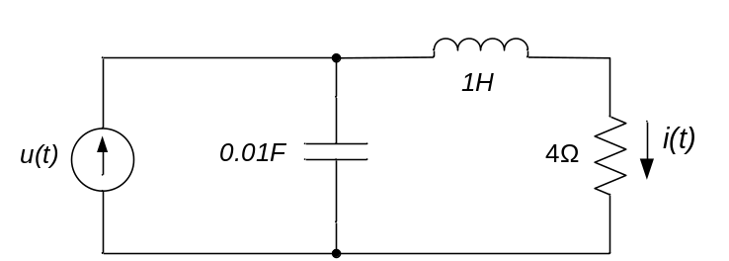
- A current in a second order circuit is described by the differential equation
$$\frac{d^{2}i(t)}{dt}+6\frac{di(t)}{dt}+100i\left(t\right)=50u_{0}(t)$$
- Determine the damping ratio, undamped natural frequency, and damped natural frequency for the circuit.
- Sketch the response of the circuit to a unit step input. Include numerical values for t_{r}, the maximum value of i(t), and the steady-state value of i(t).

- For the circuit below, determine
- The differential equation for i_{L}(t), t>0.
- The initial (t=0+) and final (t→∞) conditions on v_{C}(t) and i_{L}(t).
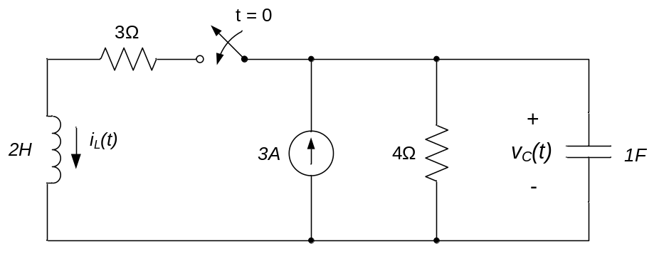

- The switch moves from position A to position B at t=0 seconds.
- Determine the differential equation that governs v_{C}(t), t>0.
- Determine initial (t=0+) and final (t→∞) conditions on v_{C}(t) and i_{L}(t).
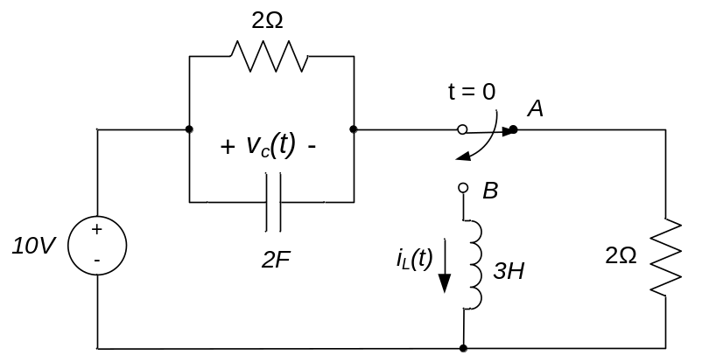

- The switch moves from position A to position B at t=0 seconds.
- Determine the differential equation that governs v_{C}(t), t>0.
- Determine initial (t=0+) and final (t→∞) conditions on v_{C}(t) and i_{L}(t).
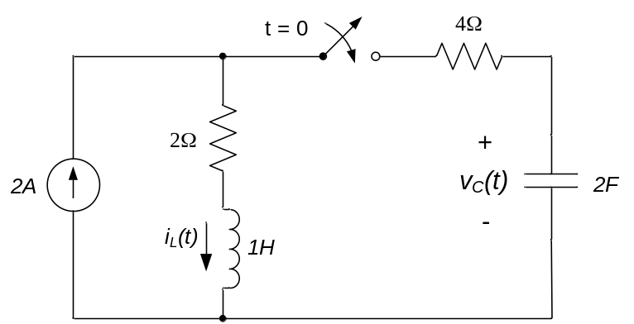

- The differential equation governing a voltage v_{out}(t) in a circuit is:
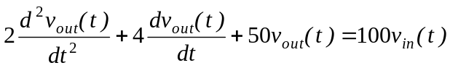
Determine the maximum value of v_{out}(t) resulting from a step voltage input
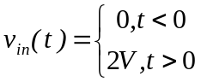.

- For the circuit below, determine
- The differential equation for i_{L}(t), t>0
- The initial (t=0+) and final (t→∞) conditions on v_{C}(t) and i_{L}(t).
