Chapter 7 Homework:
- For the circuit below, determine
- v_{C}(t), t>0
- v_{C}(t), t>0 if the capacitance is 1F
- v_{C}(t), t>0 if the capacitance is 0.25F
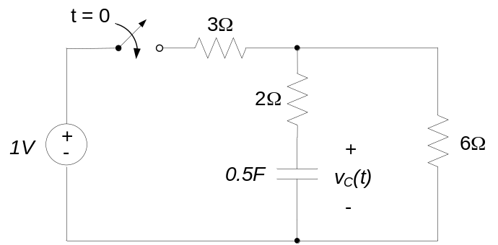

- Find v(t), t>0, in the circuit below.
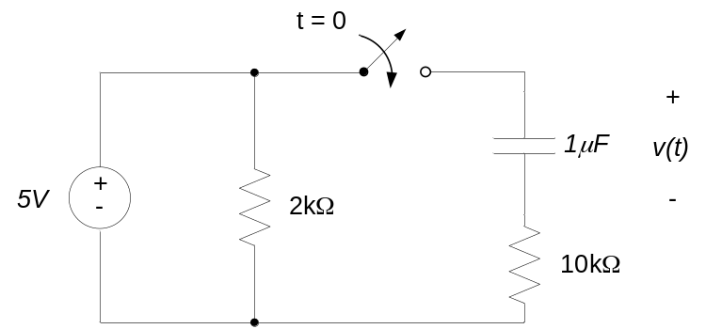

- For the circuit shown, the switch moves from position A to position B at time t = 0. Find v(t), t>0.
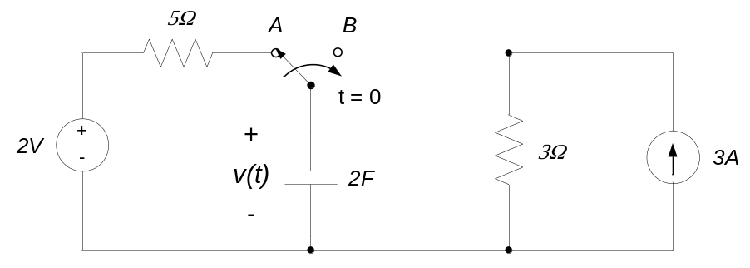

- For the circuit shown, the input is the current source u(t)=2u₀(t)A and the output is the voltage across the 6Ω resistor, y(t). Find y(t), t>0.
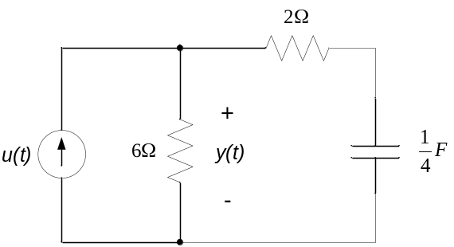
- For the circuit shown, the input is the current source u(t) and the output is the current through the inductor, y(t).
- Determine the differential equation relating u(t) and y(t).
- If u(t) = 3u₀(t), determine y(t), t>0.
- Does your answer to part (b) agree with your expectations as to the circuit’s physical behavior as t→∞? Why or why not?
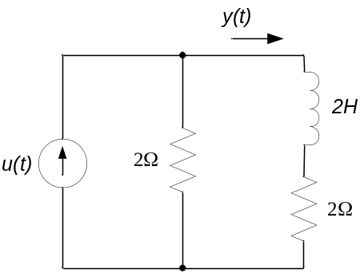
- For the circuit shown, the switch closes at time t = 0.
- Write the differential equation governing i(t), t>0.
- Determine initial (t = 0) and final (t→∞) conditions on the current i(t). You may assume that no energy is stored in the inductor before t=0.
- Find i(t), t>0.
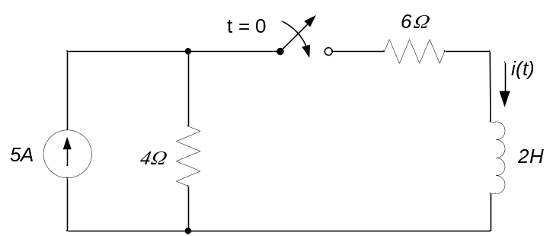

- For the circuit below, determine the differential equation relating V_{out}(t) and V_{in}(t).
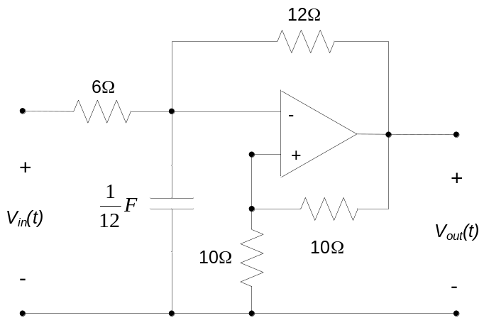

- Determine the differential equations relating Vout and Vin for the circuit below.
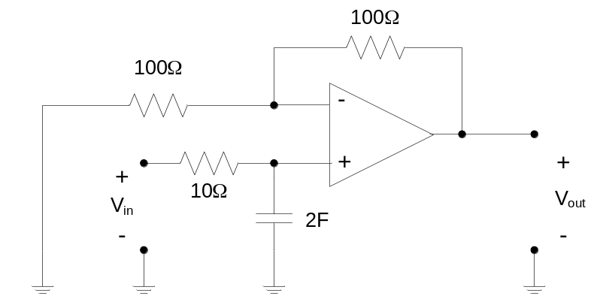

- Determine the differential equations relating Vout and Vin for the circuit below.
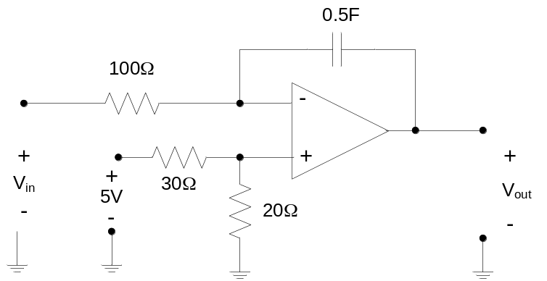

- Determine the differential equations relating Vout and Vin for the circuit below.
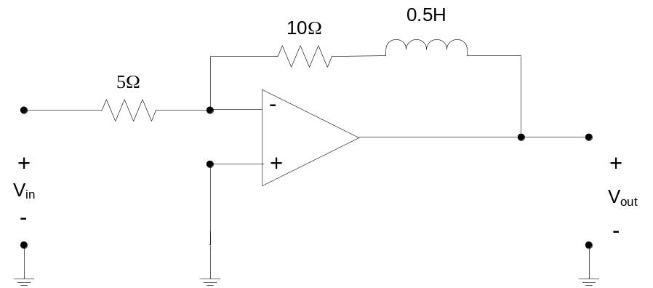

- Determine the differential equation relating V_{IN}(t) and V_{OUT}(t) for the circuit below.
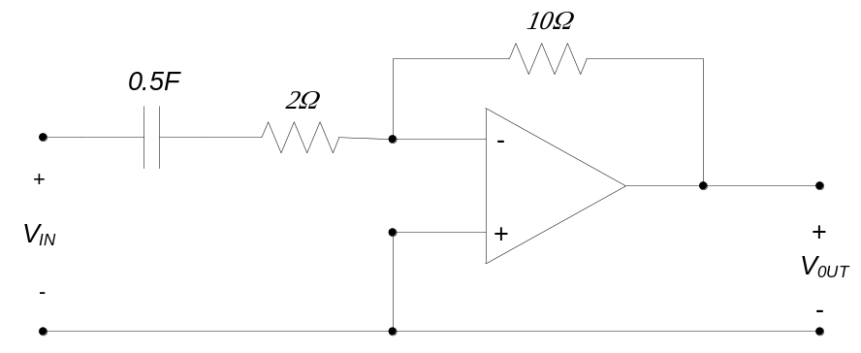

- Find V_{OUT}(t), t>0, in the circuit below.
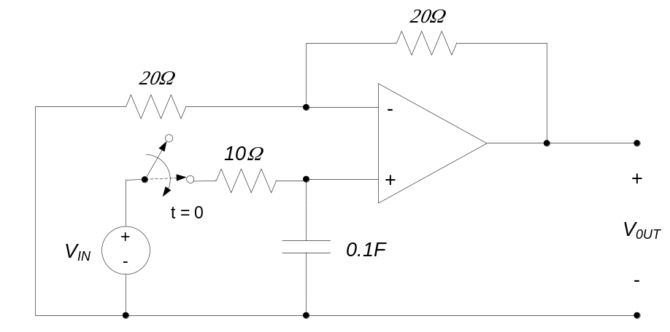

- For the circuit below, determine
- the differential equation governing V_{OUT}(t), t>0
- V_{OUT}(t), t>0.
- Does your solution for part (b) agree with your expectations, based on the circuit’s behavior as t→∞?
