Chapter 6 Homework:
- Determine the equivalent capacitance of the circuit below.
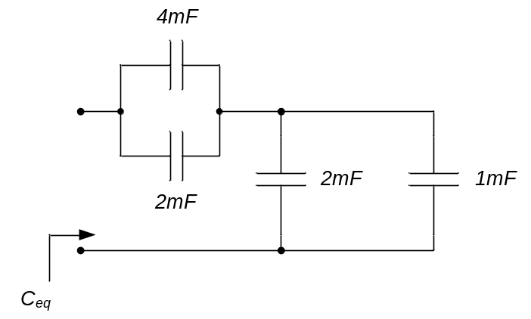

- The capacitor in the circuit to the left below is initially uncharged. A 1A current is applied to the capacitorfor 1msec, as shown to the right below. Sketch the voltage across the capacitor.
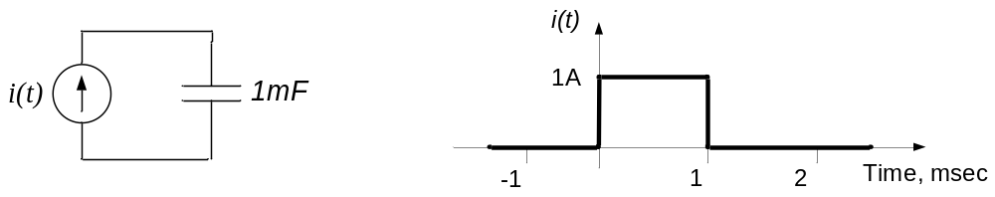

- Determine the equivalent inductance of the circuit below.
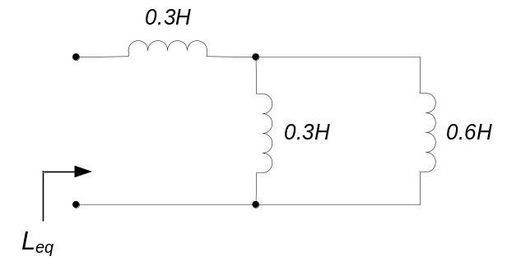

- The voltage across a 1mH inductor is as shown below. Sketch the current through the inductor. Assume that the inductor is relaxed at time t = 0.
