Chapter 5 Homework:
- For the circuit shown, find V_{out}.
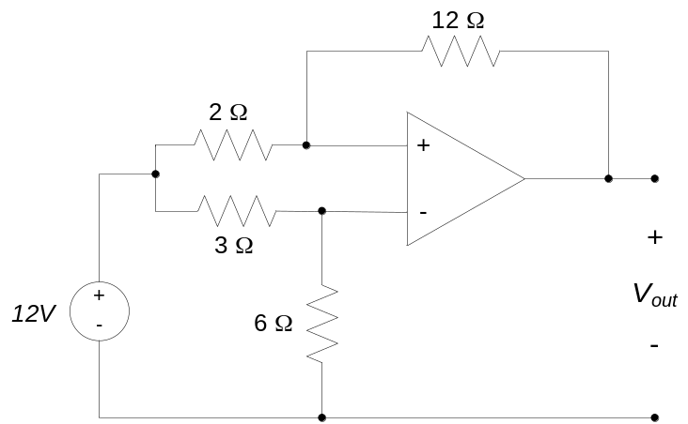

- For the circuit shown, find the relationship between V_{out} and V_{in}.
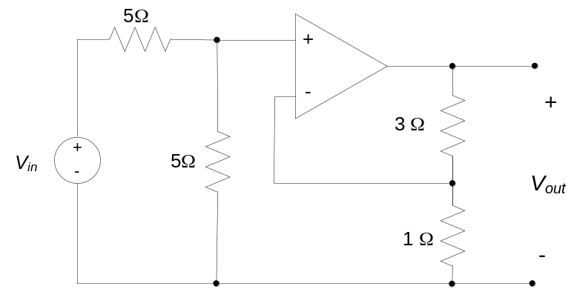

- For the circuit below find i, the current through the 16 Ω resistor.
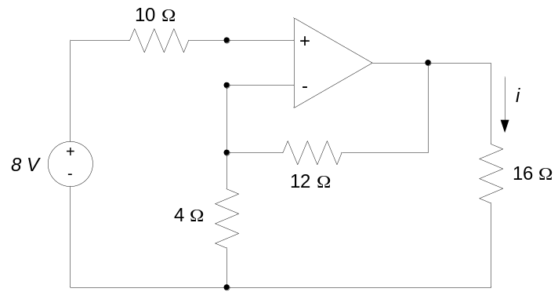
- For the circuit shown, find Vout, the voltage across the 30kΩ resistor.
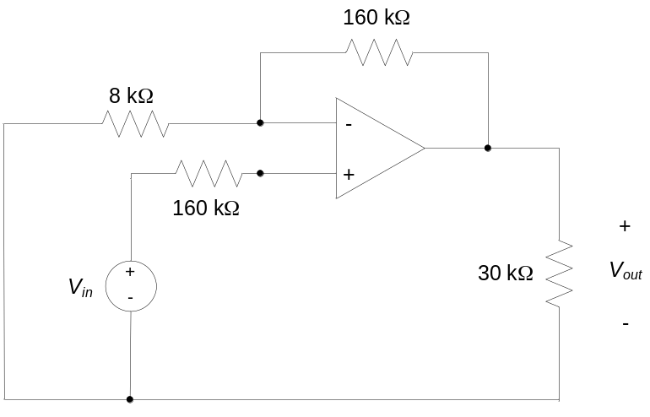

- For the circuit below, determine:
- The current, i, and voltage v_{out} if u(t) = 4V
- The current, i, and voltage v_{out} if u(t) = 2cos(5t)
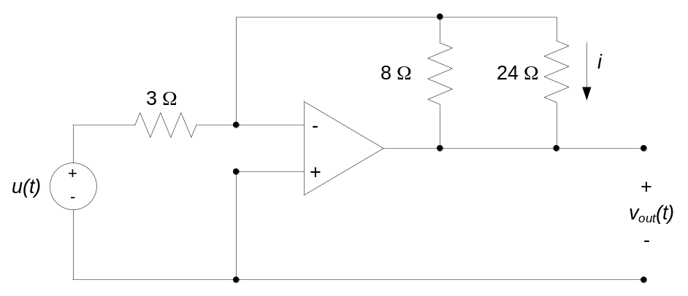

- For the circuit shown, find V_{out}.
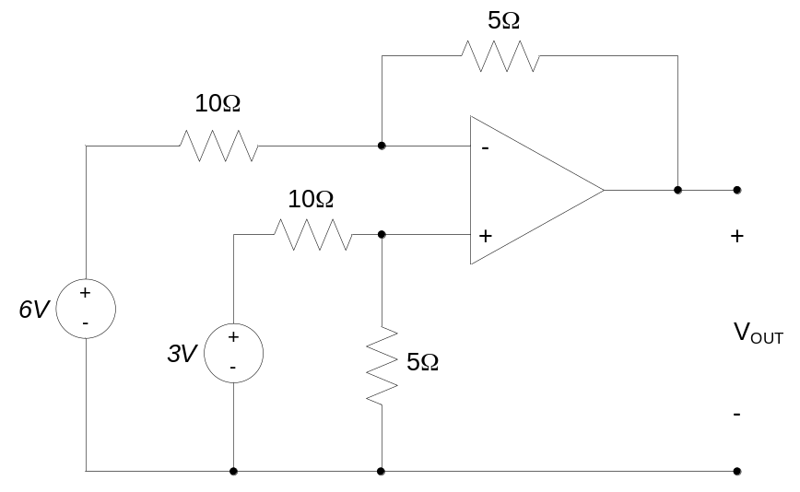

- For the circuit shown, find V_{out}.
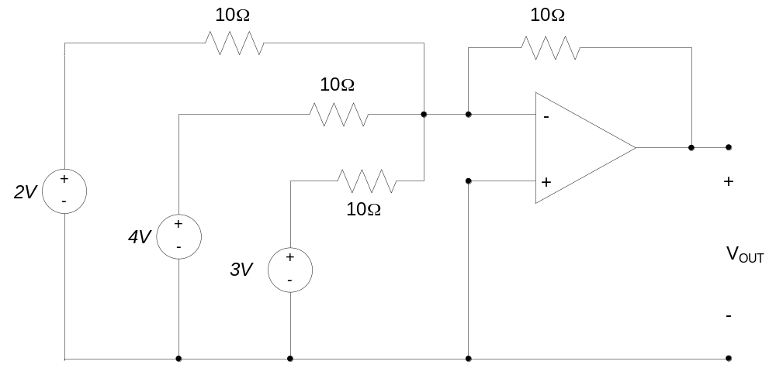

- For the circuit shown, find V_{out}.
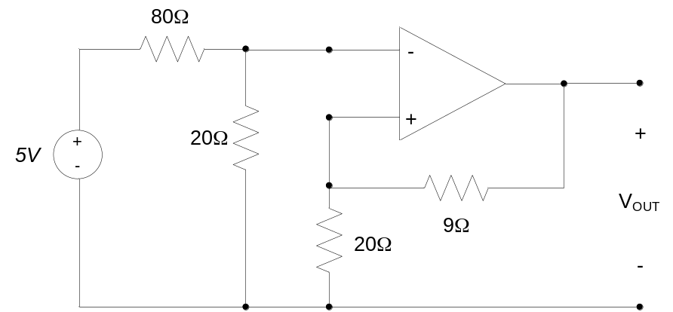

- For the circuit shown, find V_{out}.
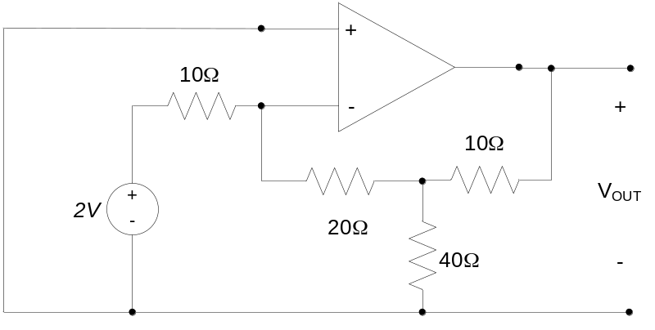

- For the circuit shown, find V_{out}.
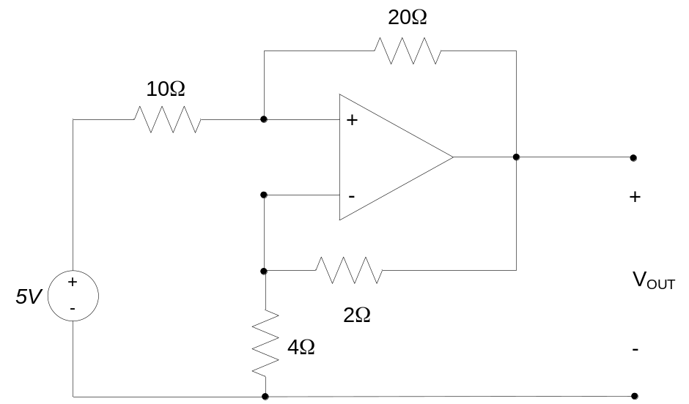

- For the circuit shown, find V_{out}.
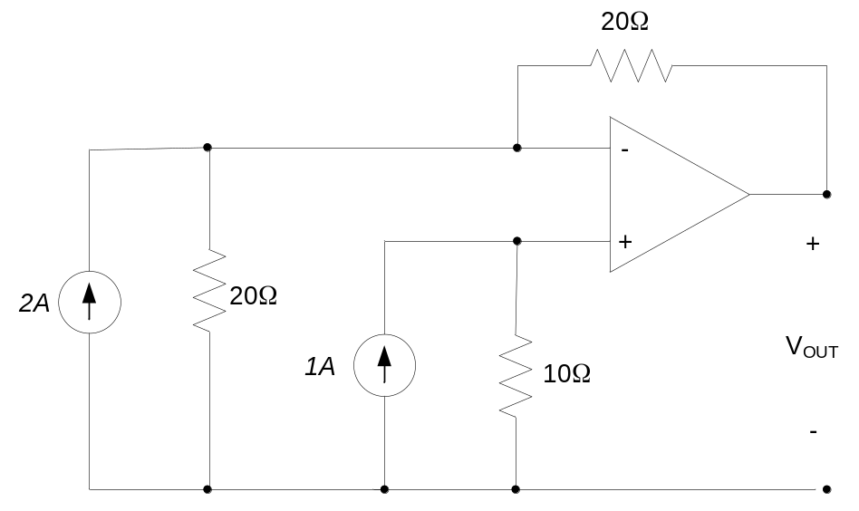

- For the circuit shown, find V_{out}.
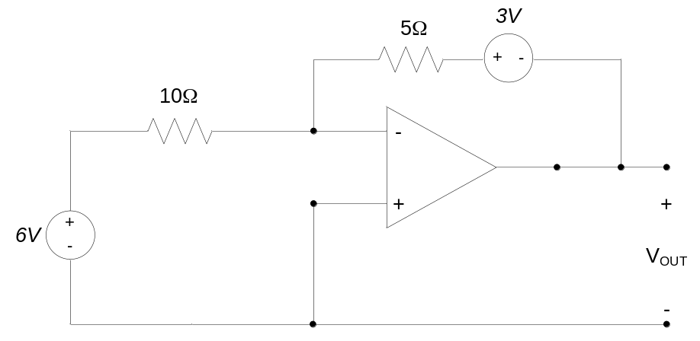

- Find the current I in the circuit below. Your answer may be a function of the voltage supply V_{S}. Clearly show all your work.
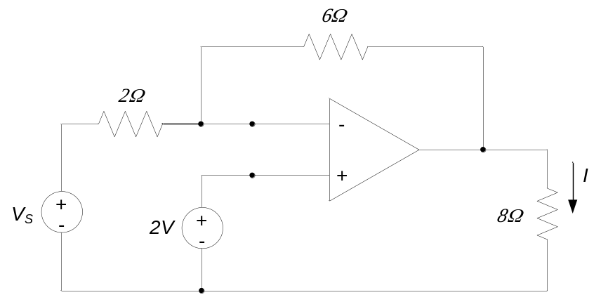

- For the circuit shown, find the voltage V_{OUT}.
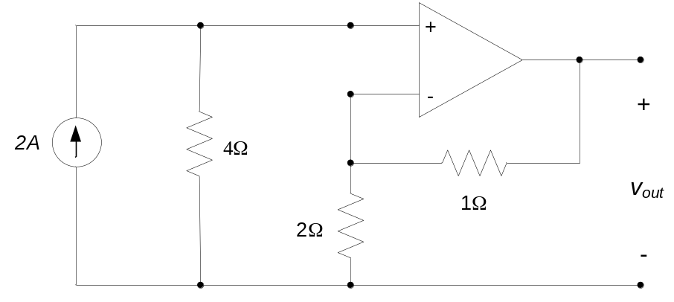

- For the circuit shown, find V_{out} as a function of V_{in}.
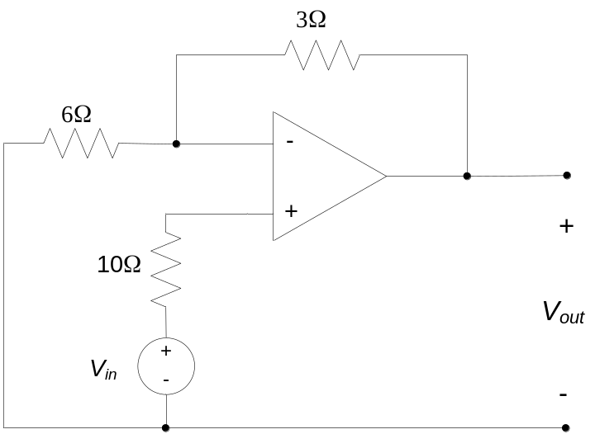

- Determine the currents i₁ and i₂ in the circuit below.
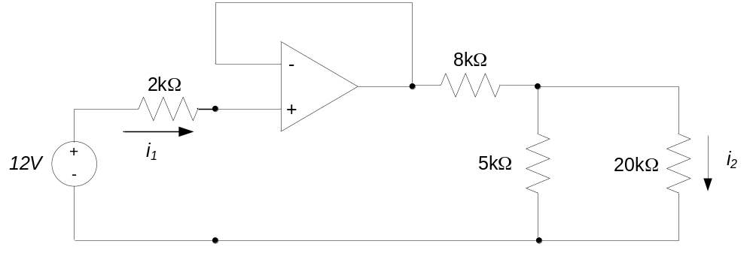

- Determine the voltage v₁ in the circuit below.
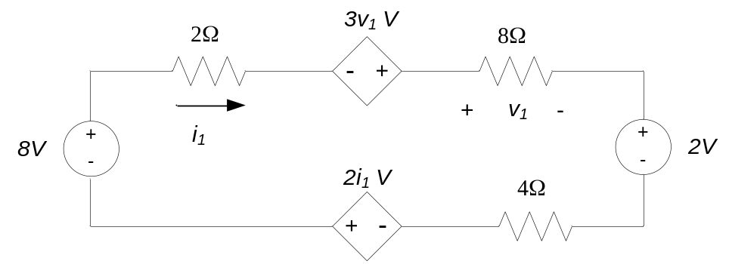

- Determine the current i₁ in the circuit below.
