Chapter 4 Homework:
- Use superposition to determine the voltage V in the circuit below. The current U is an arbitrary value.
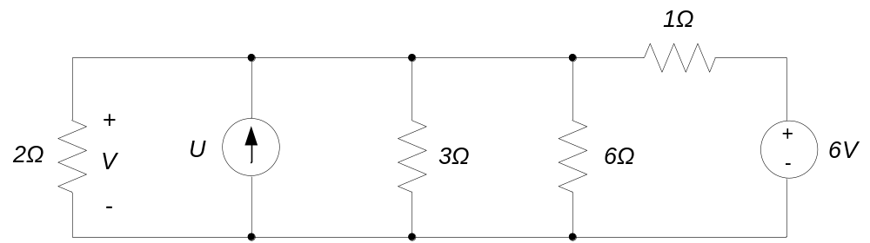

- For the circuit of problem 1, determine an input-output relationship between the current U and the voltage V. Plot the relationship between U and V, using U as the independent variable (e..g. U is on the horizontal axis.)

- For the circuit of problem 1, replace everything but the current source with its Thevenin equivalent circuit. Replace the current source in your Thevenin circuit and determine the input-output relationship between the current U and the voltage V. Does your result agree with the input-output relation you obtained in problem 2?

- For the circuit below
- Replace everything except the resistor R in the circuit below with its Thevenin equivalent circuit.
- Using your result from part (a), determine the current I if R = 3Ω.
- Determine the value of R that draws maximum power from the circuit.
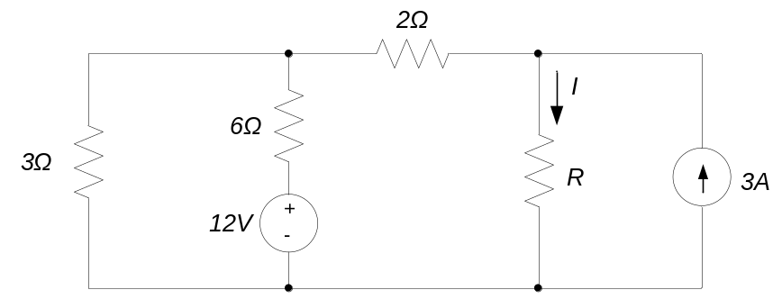
- For the circuit below
- Replace everything except the resistor R in the circuit below with its Thevenin equivalent circuit.
- Determine the value of R that draws maximum power from the circuit.
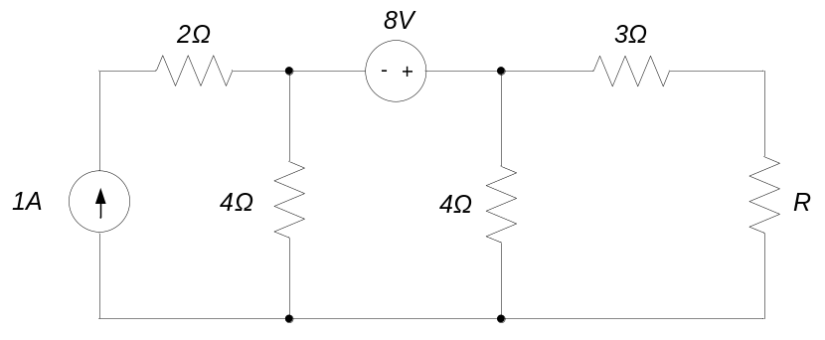

- Use superposition to determine the voltage V in the circuit below. The voltage U is an arbitrary value.
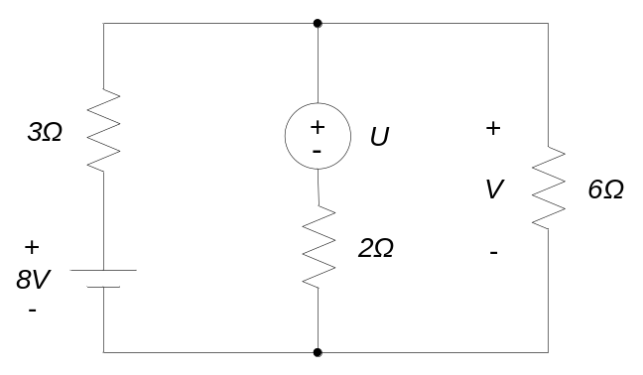

- For the circuit of problem 1, determine an input-output relationship between the voltage U and the voltage V. Plot the relationship between U and V, using U as the independent variable (e..g. U is on the horizontal axis.)

- Replace everything in the circuit below, except the 4Ω resistor, with its Thevenin equivalent circuit. Use the result to determine v_{ab}.
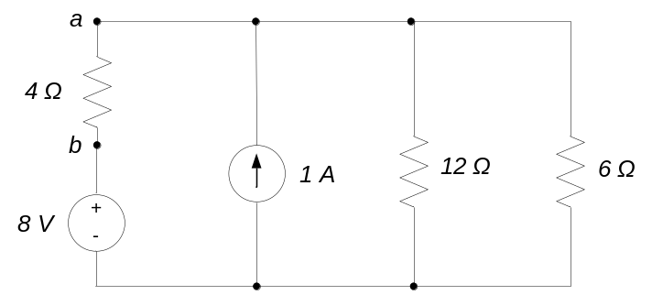

- Replace everything to the left of the terminals a-b with its Thevenin equivalent circuit. Determine the value of R that will draw the maximum power from the circuit.
