Chapter 3 Homework:
- For the circuit shown, use nodal analysis to determine the current through the 10Ω resistor.
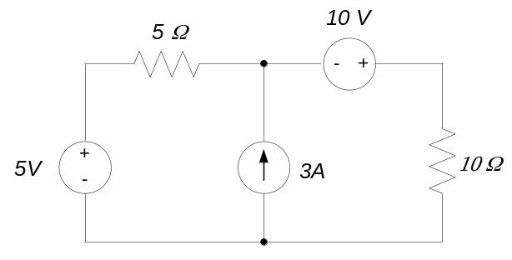

- Find the current I in the circuit below using nodal analysis.

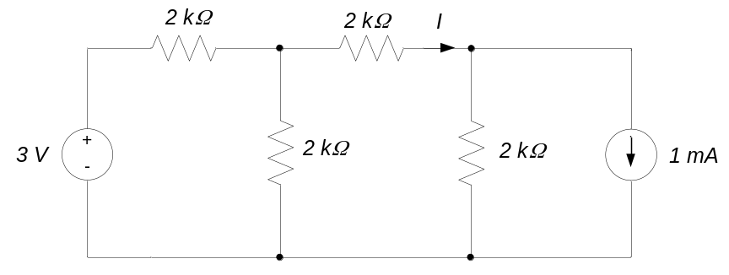

- Use nodal analysis to determine the voltage Vx in the circuit below.

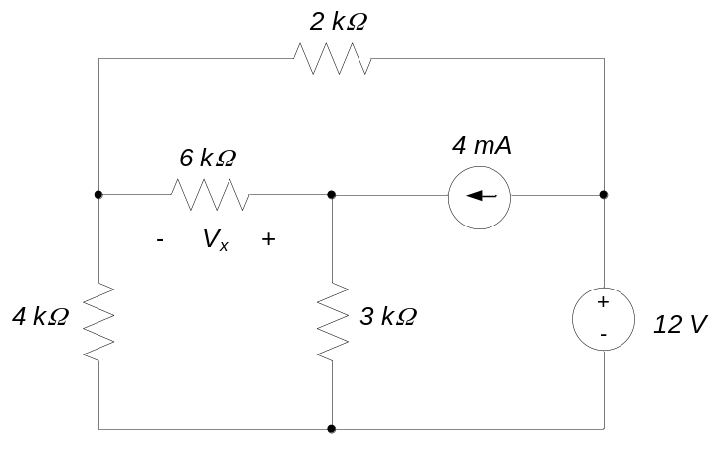

- For the circuit shown, find the current I using mesh analysis.
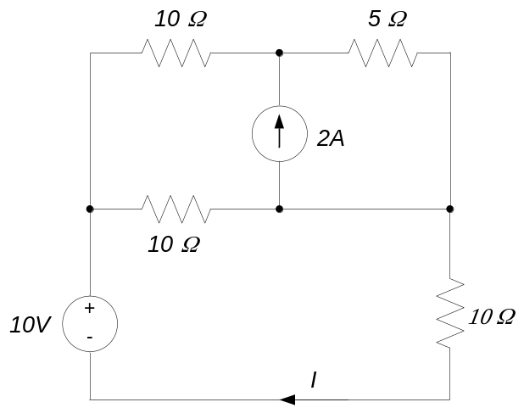

- Use mesh analysis to find the voltage V₀ in the circuit below.
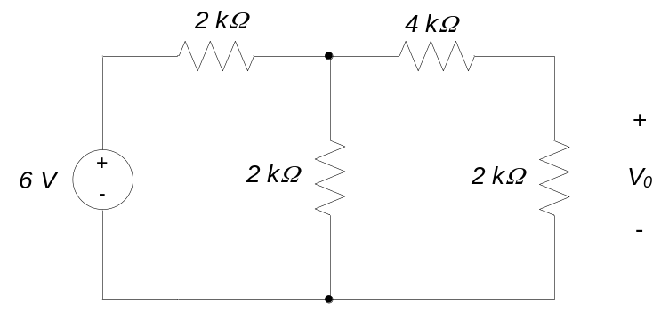

- Find v, the voltage across the 4kΩ resistor, in the circuit below using both mesh and nodal analysis.
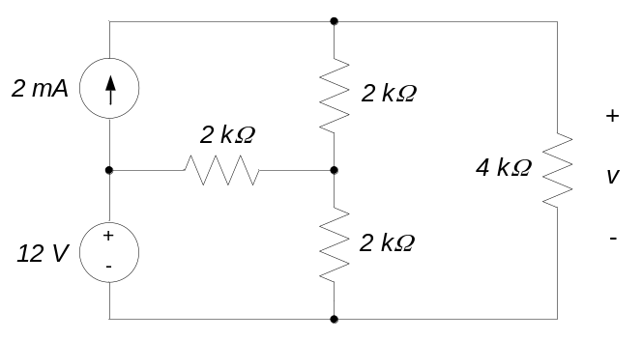

- Using mesh analysis, write a set of equations from which you can find V. It is not necessary to simplify or solve the equations for V. Clearly show all variable definitions and sign conventions.

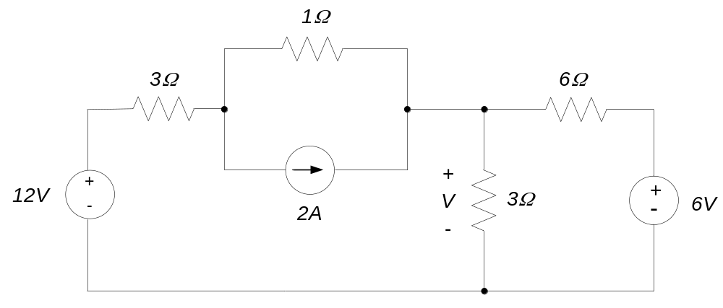

- Using nodal analysis, write a set of equations from which you can find I, the current through the 4Ω resistor. It is not necessary to simplify or solve the equations for I. Clearly show all variable definitions and sign conventions.

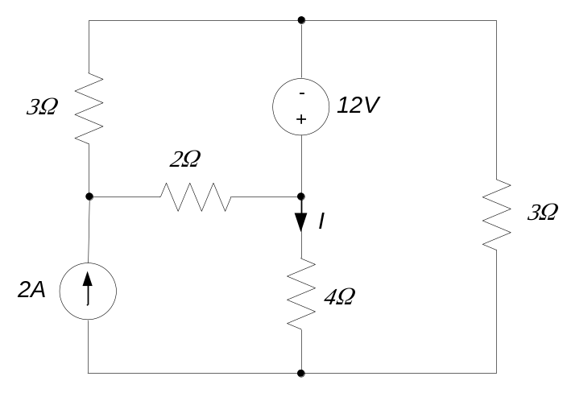

- Using mesh analysis, write a set of equations from which you can find V. It is not necessary to simplify or solve the equations for V. Clearly show all variable definitions and sign conventions.

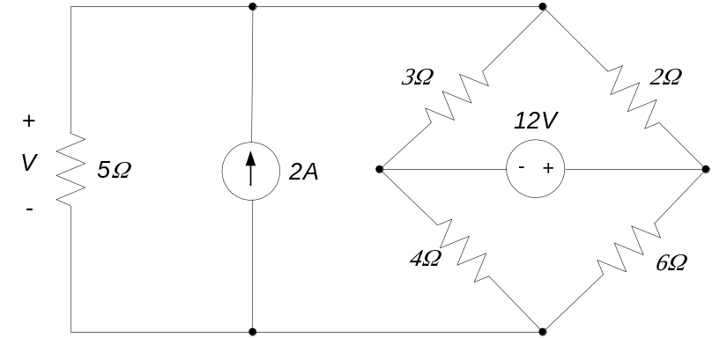

- Using nodal analysis, write a set of equations from which you can find I, the current through the 5Ω resistor. It is not necessary to simplify or solve the equations for I. Clearly show all variable definitions and sign conventions.

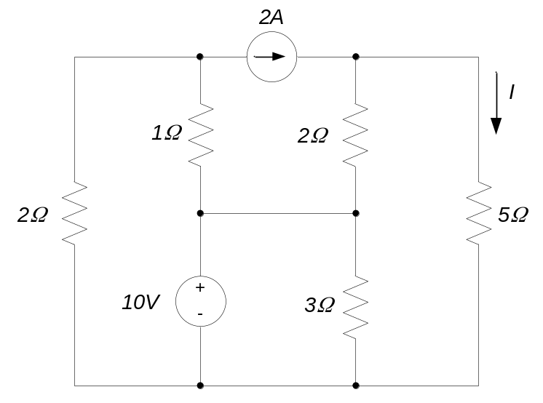

- For the circuit shown, find V₀.

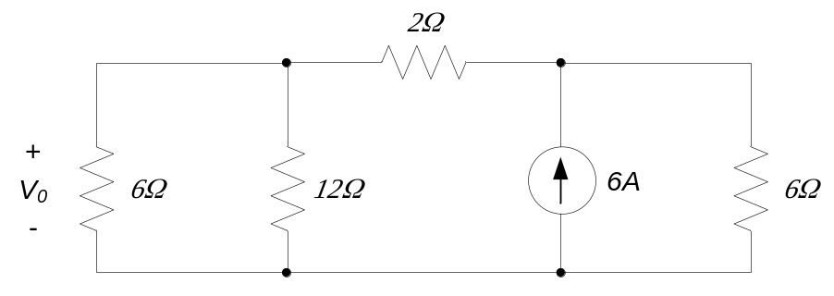

- For the circuit shown, find I₀.

