Chapter 2 Homework:
- For the circuit shown, find the voltage v_{ab} and the power (generated or absorbed) by the 20V source.
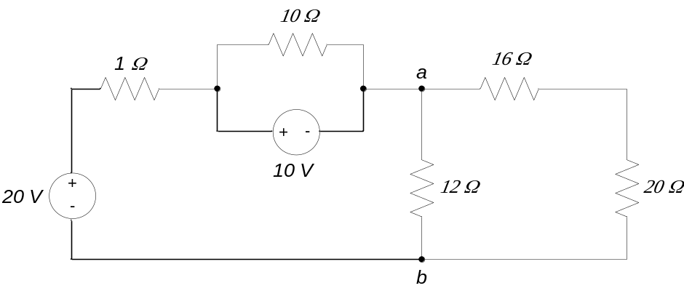
- For the circuit shown, find R_{eq} (the equivalent resistance “seen” by the source) and the current out of the source.
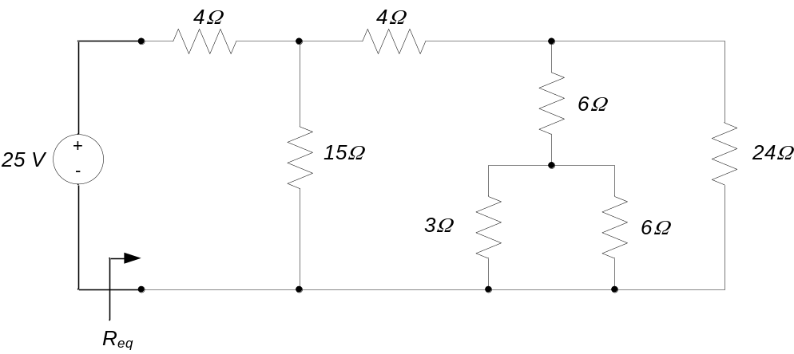
- For the circuit shown, find R_{eq} (the equivalent resistance “seen” by the source) and the current I₄.
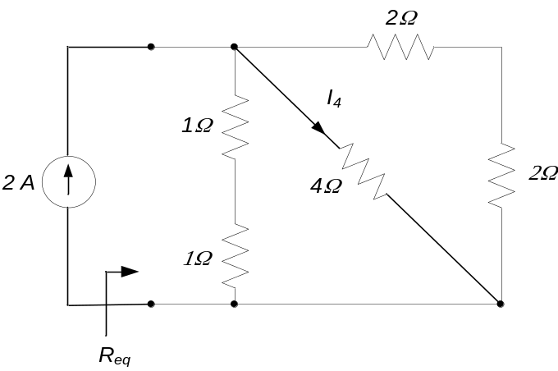
- For the circuit below, determine the current i₃.
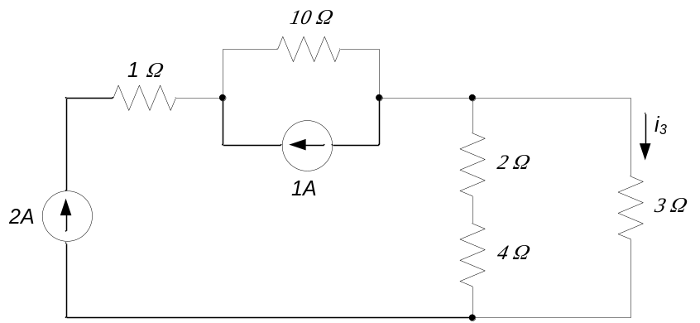

- Find V_{ab} and V₁ in the circuit below.
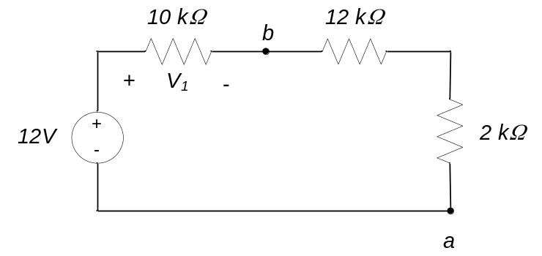

- Determine the voltage V₁ in the circuit below.
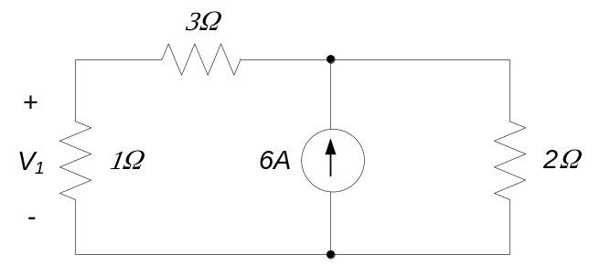

- For the circuit shown, find:
  - R_{eq} (the equivalent resistance "seen" by the source)
  - the power generated by the source
  - The current through the 4Ω resistor
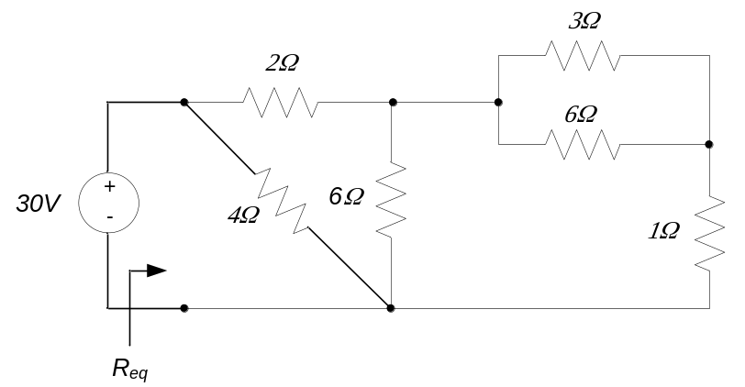

- For the circuit shown, find:
  - R_{eq} (the equivalent resistance "seen" by the source)
  - the current delivered by the source
  - The voltage difference across the 3Ω resistor.
  - The voltage difference across the 2Ω resistor.
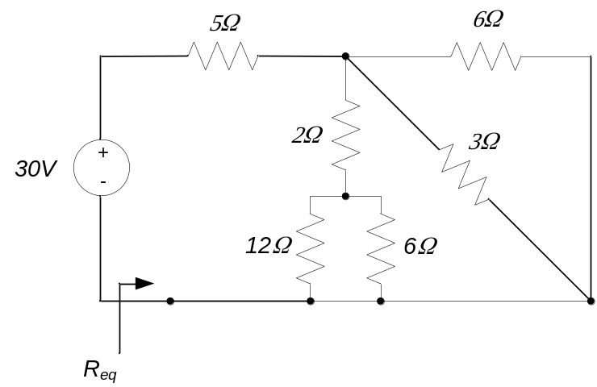

- Determine the value of the resistance R which makes the current I = 2mA.
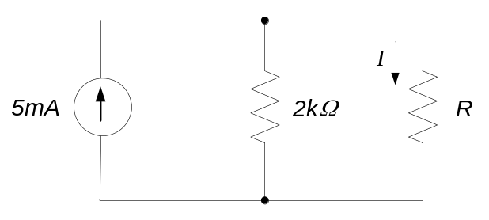

- Determine the value of the source voltage V_{S} which makes the voltage V₁ = 2V.
