Chapter 11 Homework:
- For the circuit below, the input voltage V_{in}(t) = 3cos(2t-20°) – 2cos(3t+30°) + cos(4t). Determine:
- The steady-state response of the voltage v(t).
- The steady-state response of the current i_{R}(t). (Hint: take advantage of your results from part a)
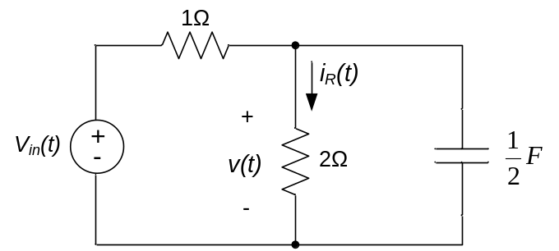

- For the circuit of problem 1, sketch the magnitude and phase response of the voltage v(t). Label your sketch at ω = 0, ω →∞ and the circuit’s cutoff frequency. Does the circuit behave as a low-pass or high-pass filter? Why?

- For the circuit below, the input is the voltage V_{in}(t). If the output is the current i(t), sketch a straight-line approximation to the Bode plot for the circuit. Label your sketch to include the DC gain and the cutoff frequency of the circuit.
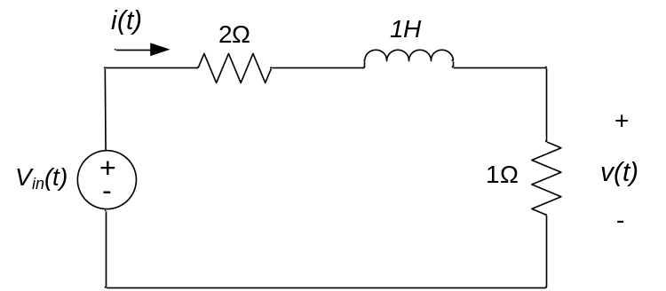

- For the circuit below, the input is the voltage u(t) and the output is the current y(t). Sketch a straight-line approximation to the Bode plot. Label your sketch to include the DC gain and the cutoff frequency of the circuit.
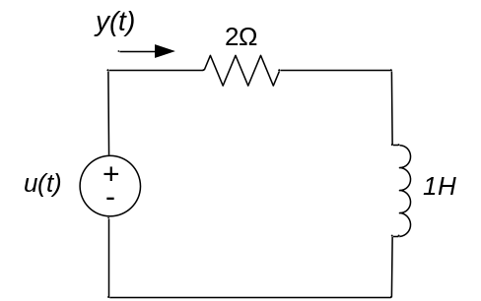

- For the circuit of problem 11.4, sketch a straight-line approximation to the Bode plot for the circuit if the output is the voltage v(t). Label your sketch to include the DC gain and the cutoff frequency of the circuit.

- For the circuit shown, the input is the voltage source u(t) and the output is the current through the inductor, y(t).
- Determine the frequency response of the circuit.
- Sketch the magnitude response of the circuit. Label your sketch to show the DC gain and the cutoff frequency of the circuit.
- Does the circuit behave as a high pass or low pass filter? Explain.
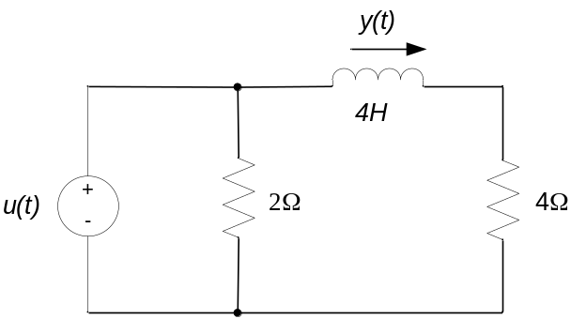

- For the circuit of problem 1, the input is the voltage source u(t). If the output is the voltage across the inductor,
- Determine the frequency response of the circuit.
- Sketch the magnitude response of the circuit. Label your sketch to show the DC gain and the cutoff frequency of the circuit.
- Does the circuit behave as a high pass or low pass filter? Explain.

- For the circuit shown, the input is the current source u(t) and the output is the current through the inductor, y(t).
- Determine the frequency response of the circuit.
- Sketch the magnitude response and phase response of the circuit. Label your sketch to show the DC gain and the cutoff frequency of the circuit.
- Does the circuit behave as a high pass or low pass filter? Explain.
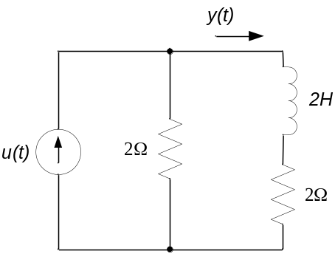

- For the circuit shown, the input is the current source u(t) and the output is the voltage across the 6Ω resistor, y(t).
- Determine the frequency response of the circuit.
- Does the frequency response you calculated above agree with your expectations as to the circuit’s response at high (ω→∞) and low (ω→0) frequencies? Why or why not?
