Chapter 1 Homework:
- For the circuit below, determine
- the voltage, V₁
- the resistance, R
- the current, I_{s}
- the power (absorbed or supplied) by the current source
- the power (absorbed or supplied) by the 3V voltage source
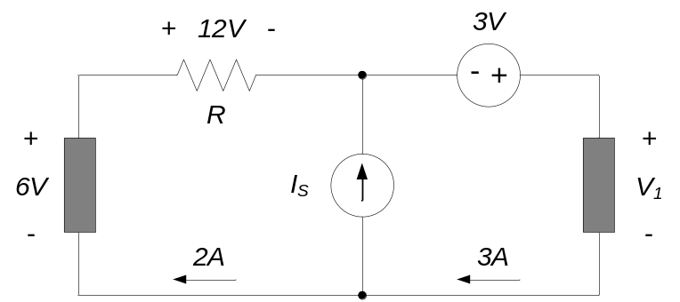

- Find I₁ and V₁ in the circuit below.
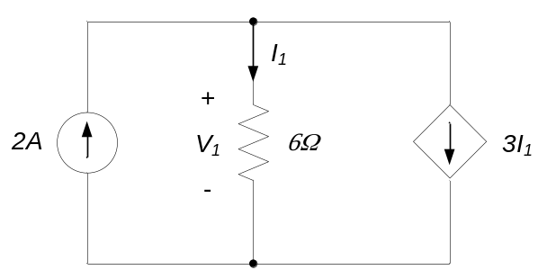

- In the circuit below, determine v_{ab}, v_{ac}, and v_{cb}.
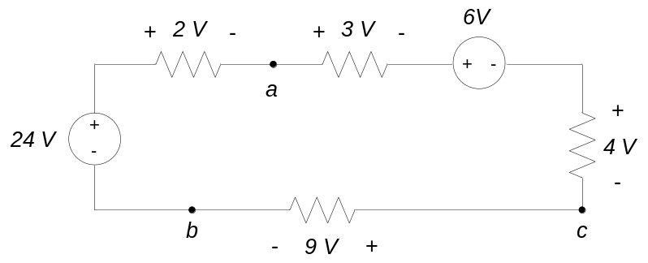

- For the circuit shown, find:
- Vs
- R₁
- Power absorbed or generated by the 10V source. State whether the power is absorbed or generated.
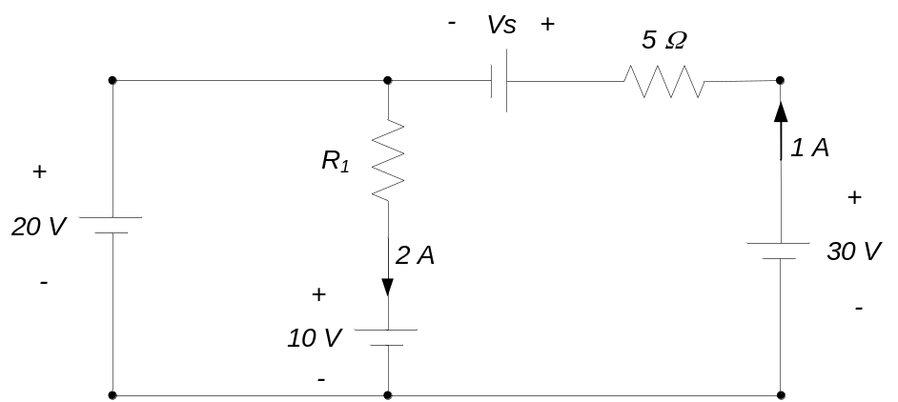

- Find V_{ab} and V₁ in the circuit below.
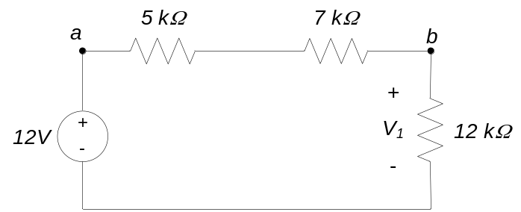

- For the circuit below, determine
- the power dissipated by the 6Ω resistor
- the voltage across the 4Ω resistor
- the current through the 2Ω resistor
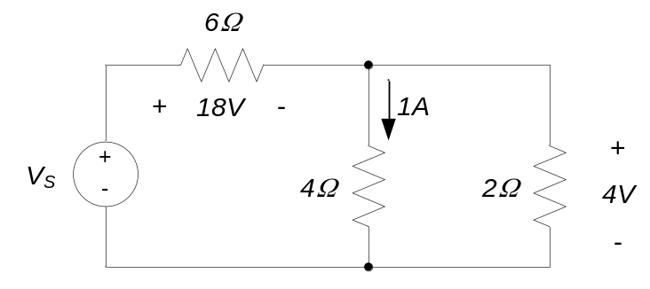

- For the circuit elements below, determine the power generated or absorbed by the element. State whether the power is generated or absorbed.
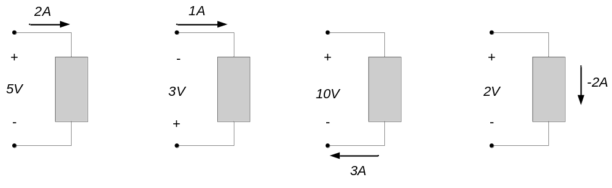
(a) (b) (c) (d)

- For the circuit below, determine
- the power dissipated by the 6Ω resistor
- the voltage across the 3Ω resistor
- the current through the 4Ω resistor
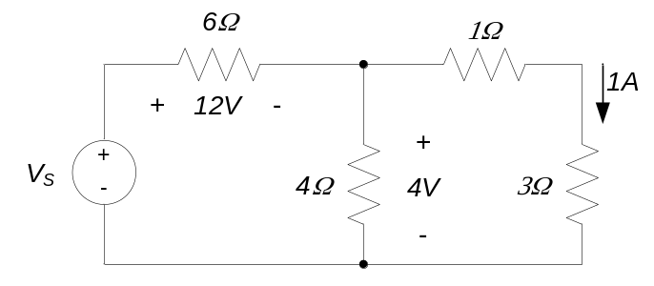

- For the circuit elements below, determine the power generated or absorbed by the element. State whether the power is generated or absorbed.
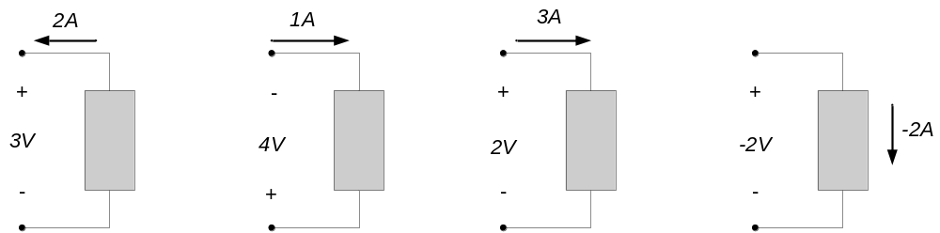
(a) (b) (c) (d)

- In the circuit below, determine v_{ab}, v_{ac}, and v_{cb}.
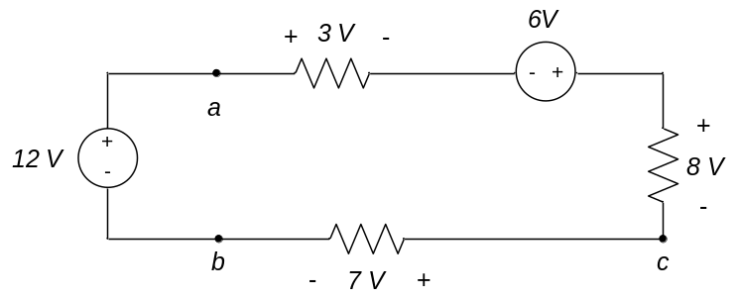

- In the circuit below, determine the power (absorbed or generated) by the voltage source V_{S.}
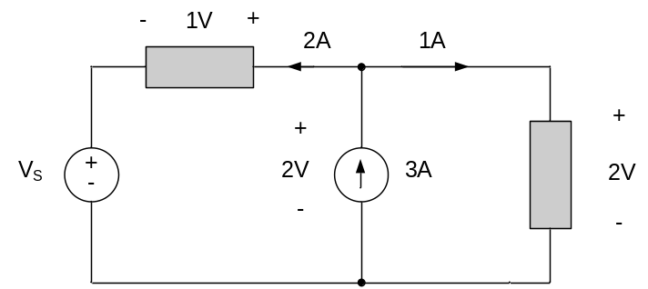

- For the circuit shown, find:
- V₁
- R₁
- The power (generated or absorbed) by the 1A source
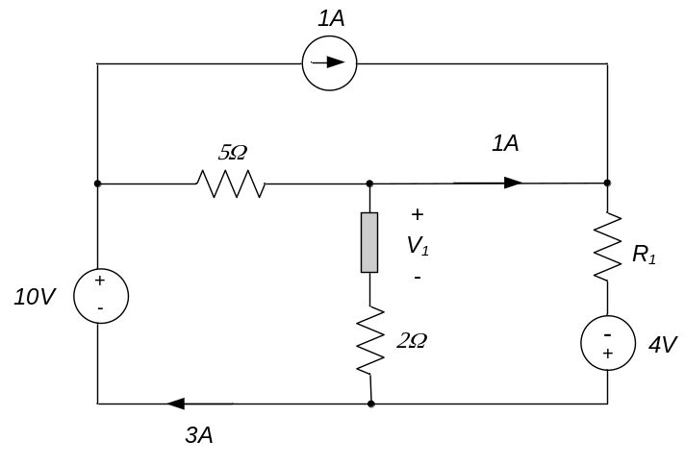

- For the circuit shown, find:
- V_{S}
- R
- The power (generated or absorbed) by the 2A source
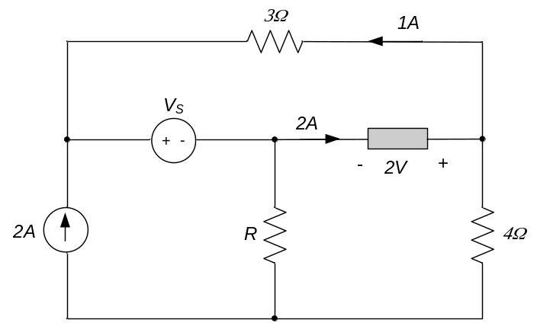

- Write a set of equations from which you can determine the current V₁ in the circuit below. You do not need to solve the equations.
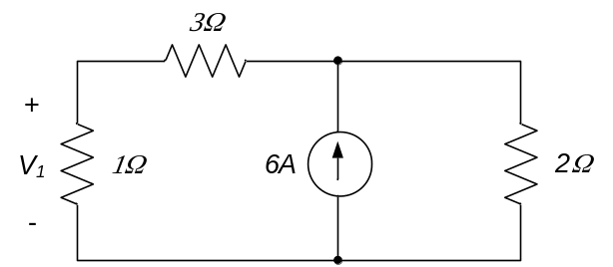

- For the circuit below, determine the voltage v_{x}, the voltage v_{ab}, and the power (generated or absorbed) by the 3A source.
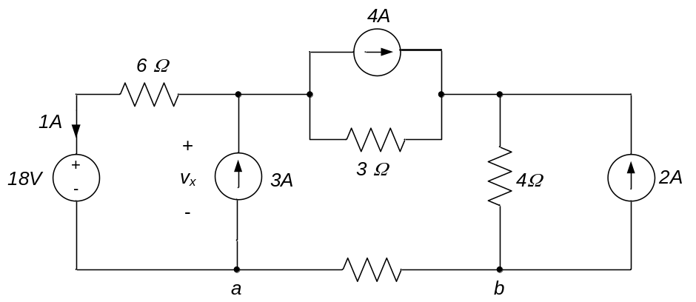

- For the circuit shown, find the voltage v_{x} and the current i₄.
